***RAO BAHADDUR Y MAHABALESHWARAPPA ENGINEERING COLLEGE,BALLARI.***

***DEPARTMENT OF ELECTRONICS AND COMMUNICATION ENGINEERING***

***A MINI PROJECT ON:***

***“3-WAY TRAFFIC LIGHT CONTROLLER USING ARDUINO”***

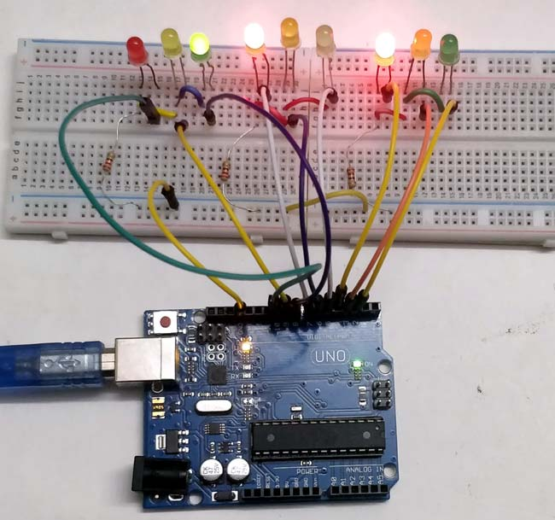

*Submitted by,*

*Arpitha Alwandi [3VC18EC005]*

*Gowri T [3VC18EC019]*

*R S Mrinalini [3VC18EC041]*

*S Vidhya Shree [3VC18EC044]*

***3- WAY TRAFFIC LIGHT CONTROLLER USING ARDUINO***

This project is very useful to understand the working of traffic lights which we see around us.

The main part of this project is the Arduino which will control the LEDs and their timings to guide the vehicles.

These control systems consists of electromechanical controllers with clock work mechanisms or modern solid state computerised systems with easy setup and maintainance.

**INTRODUCTION:**

Traffic signals are used to control the flow of vehicles .In the recent years, the need of transportation has gained immense importance for logistics as well as for common human. This has given raise to the number of vehicles on the road, Due to this reason, traffic jams and traffic accidents are a common site in a busy city. Traffic signals provide an easy, cheap, automatic and justified solution to the road points where the vehicles may turn to other directions. Example, roundabouts, culverts, busy walk throughs, etc.

**BASIC IDEA:**

The project we have chosen is 3-way control of traffic light. The basic idea behind the design is to avoid the collision of vehicles by providing appropriate signals to different directions for a limited time slot, after which the next waiting drivers will be given the same treatment. In this way, a cycle will be established which will control the traffic.

**CONTROL SIGNALS:**

The control signals are 3 lights.

RED[Stop]

YELLOW[Wait]

GREEN[Go]

***Components Required:***

|  |  |  |
| --- | --- | --- |
| ***S.No:*** | ***Components:*** | ***Quantity:*** |
| ***1*** | ***Red LED lights*** | ***3*** |
| ***2*** | ***Green LED lights*** | ***3*** |
| ***3*** | ***Yellow LED lights*** | ***3*** |
| ***4*** | ***220 ohms resistors*** | ***3*** |
| ***5*** | ***Breadboard*** | ***1*** |
| ***6*** | ***Male to male connectors*** | ***Few*** |
| ***7*** | ***Arduino UNO with Ide cable*** | ***1*** |

***Circuit Explanation:***

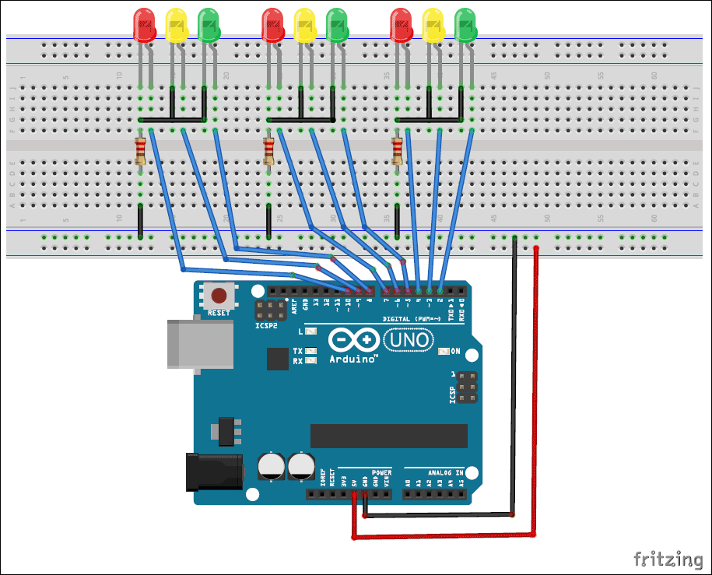

1. Connect the LEDs in order as Red, Green, and Yellow in the breadboard.
2. Place the negative terminal of the LEDs in common and connect the 220ohm resistor in series.
3. Connect the connecting wires accordingly.
4. Connect the other end of the wire to the Arduino Uno in the consecutive pins(2,3,4,5,6,7,8,9,10).
5. Power up the breadboard using the Arduino 5V and GND pin.

***Program and Working explanation:***

In this project, we demonstrated the traffic lights for the 3 ways road and the code glows LEDs on all the three sides in a particular sequence, in which the actual traffic lights works like, at a time, there will be two Red signals on any of the two sides and one Green light on the remaining side.

And, yellow light will also glow, for 1 second each time, in between transition from Red to Green, means first Red light glows for 5 seconds, then yellow light glows for 1 second and then finally, green light will be turned on.

In the program, first we have declared pins(2,3,4,5,6,7,8,9,10) as output in *void setup()* for 9 LEDs( three on each side, i.e., forward, right and left side)

void setup() {

//configure the output pins

pinMode(2,OUTPUT);

pinMode(3,OUTPUT);

pinMode(4,OUTPUT);

pinMode(5,OUTPUT);

pinMode(6,OUTPUT);

pinMode(7,OUTPUT);

pinMode(8,OUTPUT);

pinMode(9,OUTPUT);

pinMode(10,OUTPUT);

}

Then, in *void loop()* function, we have written the code for traffic lights to be turned on and off in sequence as mentioned above.

void loop()

{

digitalWrite(2,1); //enables the 1st set of lights

digitalWrite(7,1);

digitalWrite(10,1);

digitalWrite(4,0);

digitalWrite(3,0);

digitalWrite(6,0);

digitalWrite(8,0);

digitalWrite(9,0);

digitalWrite(5,0);

delay(5000);

……. ……-

……. ……

First, the forward side is opened (green), while the other two sides,i.e., the left side and the right side remains close with Red signal with a delay of 5 seconds. Then, the yellow light gets turned on at the right side for 1 sec followed by the Green light, leaving the other two sides,i.e., the upside and left side is Red, closed with red light and 5 secs delay. Then, yellow on the left side glows for 1 sec, followed by green one leaving upside and rightside Red with 5sec delay.

This process is looped in *void loop()* function for continuous process.

Here, we can modify the delays for which the Red, Yellow and Green light remains ON and OFF.

**Advantages:**

This provides for the orderly movement of traffic.

They increase the traffic handling capacity of the intersection if:

1. Proper physical layouts and control measures are used.
2. To maximise the ability of traffic control signal to satisfy current traffic demands.

They are coordinated to provide for continuous or nearly continuous movement of traffic at a definite speed along a given route under favourable conditions.

Protect pedestrians from accidents.

They provide economy over manual control at the intersection.

**Disadvantages:**

Excessive delays can translate to wasted fuel, air pollution and costs to motorists.

By waiting till the signals on, drivers can get unnecessarily impatient and aggressive when driving. And, this leads at accidents, congestions, not following traffic rules.